# Description: Herring (Clupea harengus) in Division 6.a South (South of 56°00’N and West of 07°00’W) and 7.b-c (northwest and west of Ireland)

## Section her.27.6aS7bc

### Subsection

Length frequency plots for each year including mean length at first capture are shown in Figure .

Details of the catch, TAC, advice, survey biomass and length based indicator parameters by year are shown in Table .

A summary of the resulting catch advice is shown in Table .

The advised catch, taking the stability clause into account, is 1708.891

## References

**Table** : Catch advice summary

| Parameter | Value |
| --- | --- |
| Ay (previous advice) | 2,270.000 |
| Iy-1 (latest survey SSB, t) | 100,523.000 |
| Fproxy,MSY | 0.034 |
| b (biomass safeguard) | 1.000 |
| m (multiplier) | 0.500 |
| chr (Cy+1 = Iy-1 × Fproxy,MSY × b × m) | 1,709.000 |
| % Change (from previous advice) | -25.000 |
| Stability clause applied (-30% or +20%) | 1,708.891 |
| Advised Catch | 1,708.891 |

**Table** : catch, TAC, advice, survey biomass and length based indicator parameters by year

| Year | Survey_Index | ICES_landings | TAC | ICES_advice | Modal_catch | Lc | MeanL_c | Median | TargetRefLen | f | CyIy | Fproxy | Inv_f |
| --- | --- | --- | --- | --- | --- | --- | --- | --- | --- | --- | --- | --- | --- |
| 2,014 | 149,270 | 5,096 |  |  | 28.0 | 26.0 | 27.996 | 27.5 | 27.958 | 1.001 | 0.034 | 0.034 | 0.999 |
| 2,015 | 226,293 | 1,078 |  |  | 27.0 | 26.5 | 27.680 | 26.5 | 28.241 | 0.980 | 0.005 | 0.034 | 1.020 |
| 2,016 | 36,707 | 2,213 | 1,630 | 0 | 28.0 | 25.0 | 27.298 | 26.5 | 27.393 | 0.996 | 0.060 | 0.034 | 1.003 |
| 2,017 | 66,342 | 2,227 | 1,630 | 0 | 26.0 | 25.0 | 27.006 | 26.5 | 27.393 | 0.986 | 0.034 | 0.034 | 1.014 |
| 2,018 | 96,138 | 1,495 | 1,630 | 0 | 27.0 | 25.5 | 27.184 | 26.5 | 27.676 | 0.982 | 0.016 | 0.034 | 1.018 |
| 2,019 | 92,364 | 1,690 | 1,630 | 0 | 25.5 | 23.0 | 26.170 | 25.0 | 26.264 | 0.996 | 0.018 | 0.034 | 1.004 |
| 2,020 | 135,335 | 1,220 | 1,360 | 0 | 24.0 | 22.5 | 25.030 | 24.0 | 25.981 | 0.963 | 0.009 | 0.034 | 1.038 |
| 2,021 | 189,856 | 1,821 | 1,360 | 0 | 25.5 | 24.5 | 25.993 | 25.0 | 27.111 | 0.959 | 0.010 | 0.034 | 1.043 |
| 2,022 | 147,199 | 1,326 | 1,360 | 0 | 26.0 | 24.5 | 26.117 | 25.5 | 27.111 | 0.963 | 0.009 | 0.034 | 1.038 |
| 2,023 | 100,523 | 1,255 | 1,892 | 1,892 | 26.0 | 24.5 | 26.187 | 25.5 | 27.111 | 0.966 | 0.012 | 0.034 | 1.035 |

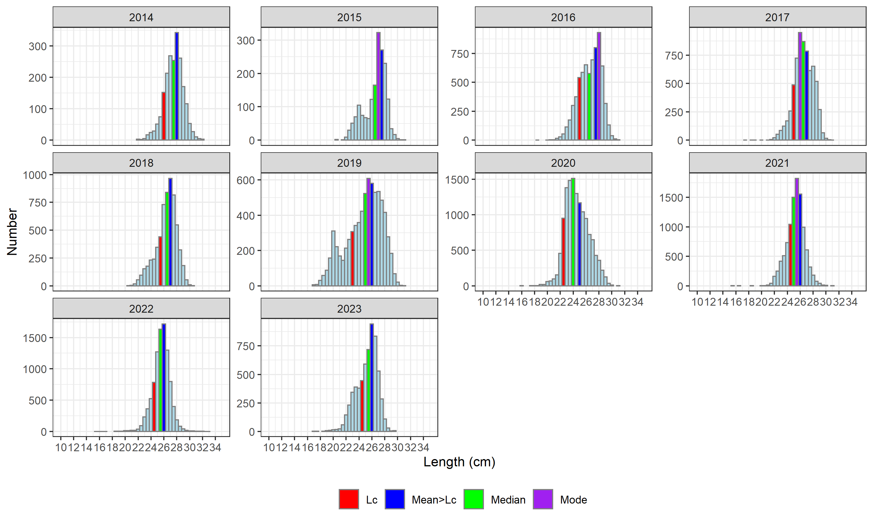

**Figure** : Stock in 27.6aS7bc Length Frequency plots by year.